Matrices

Without going into too much detail, a matrix is a mathematical array of 4 columns times 4 rows.  
They look something like this:

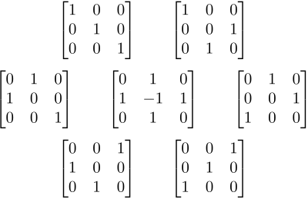

Matrices are used to transform vectors, which as defined earlier, compose our shape.   
The way we transform a vector is by multiplying the left hand side by what we call the “transformation matrix”, which will allow us to move objects around on the screen.  
In this case, the top left matrix is the identity matrix, it’s the untransformed, original matrix. From there, judging on how the columns have changed, we can identify the transformation (reflection in this case).